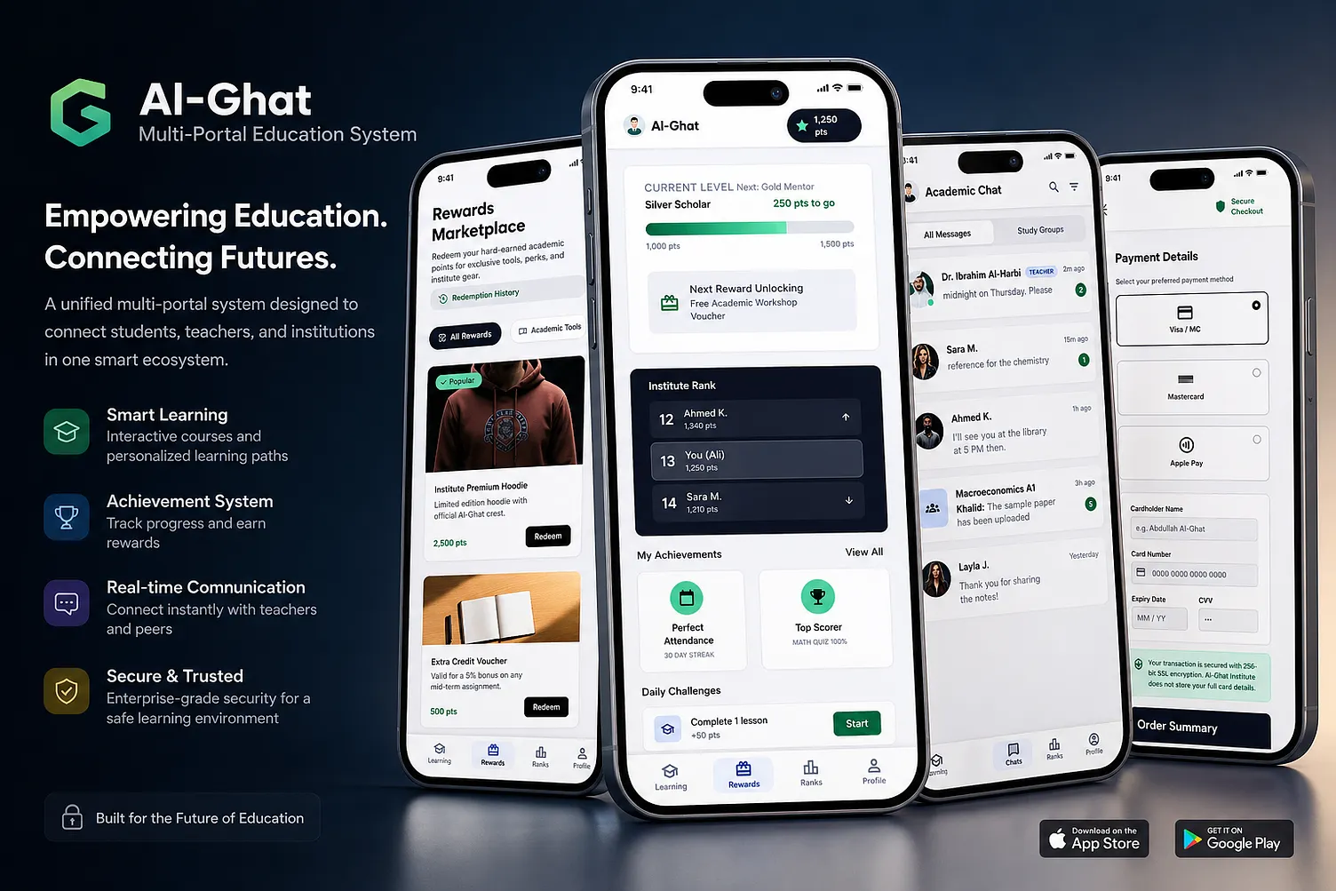

DSD (Detailed System Design)

Project Title
AI-Ghat: Multi-Portal Education Management System

Problem Statement
Educational institutions often use separate platforms for attendance, assignments, communication, fee payments, and academic performance. This causes inefficiency, poor communication, and data duplication.
The proposed system provides a unified platform for students, teachers, parents, and administrators with AI-powered learning support, progress tracking, communication, and analytics.

System Architecture
+---------------------+
| React Frontend |
+----------+----------+
|
v
+---------------------+
| Node.js Express |
| Backend |
+----------+----------+
|
-------------------
| | |
v v v
MySQL AI APIs Cloud Storage
Database OpenAI Documents

User Portals

1. Student Portal

Features
- Student Dashboard
- Attendance Tracking
- Course Enrollment
- Assignment Submission
- AI Learning Assistant
- Academic Chat
- Progress Analytics
- Rewards & Achievements
- Notifications
- Fee Payment

Inputs
- Assignment files
- Questions to AI
- Profile information

Outputs
- Grades
- Attendance reports
- Personalized recommendations

2. Teacher Portal

Features
- Manage Courses
- Upload Notes
- Create Assignments
- Evaluate Submissions
- Attendance Management
- Student Performance Analytics
- AI Question Generator
- Student Communication

Outputs
- Marksheets
- Performance reports

3. Parent Portal

Features
- Attendance Monitoring
- Fee Status
- Student Performance
- Teacher Communication
- Notifications

4. Admin Portal

Features
- User Management
- Course Management
- Fee Management
- Reports Generation
- Institution Analytics
- Security Management

Functional Modules

Module 1: Authentication

Functions
- Login
- Registration
- Forgot Password
- Role-Based Access

Roles
- Student
- Teacher
- Parent
- Admin

Module 2: Learning Management System

Features
- Video Lectures
- Notes Repository
- Assignments
- Quizzes
- Certificates

Module 3: AI Academic Assistant

Features
- Doubt Solving
- Study Recommendations
- Quiz Generation
- Learning Path Suggestions
AI-assisted tutoring and personalized learning are common educational AI use cases.

Module 4: Attendance Management

Features
- Manual Attendance
- QR Attendance
- Attendance Reports

Module 5: Communication System

Features
- Real-time Chat
- Group Discussions
- Announcements
- Notifications

Module 6: Rewards System

Features
- Points for Attendance
- Quiz Rewards
- Badges
- Leaderboard
Inspired by the rewards and ranking screens shown in the AI-Ghat concept.

Database Design

Student Table
Field | Type
student_id | INT
name | VARCHAR
email | VARCHAR
course | VARCHAR
attendance | FLOAT

Teacher Table
Field | Type
teacher_id | INT
name | VARCHAR
department | VARCHAR
email | VARCHAR

Course Table
Field | Type
course_id | INT
course_name | VARCHAR
teacher_id | INT

Assignment Table
Field | Type
assignment_id | INT
course_id | INT
due_date | DATE

Attendance Table
Field | Type
attendance_id | INT
student_id | INT
date | DATE
status | VARCHAR

Use Case Diagram
Student
|
+--> View Courses
+--> Submit Assignment
+--> Chat
+--> AI Assistant
+--> Pay Fees

Teacher
|
+--> Manage Courses
+--> Take Attendance
+--> Grade Students

Parent
|
+--> View Reports
+--> Monitor Attendance

Admin
|
+--> Manage Users
+--> Generate Reports

Technology Stack

Frontend
- React.js
- Tailwind CSS
- React Router
- Axios

Backend
- Node.js
- Express.js

Database
- MySQL

Authentication
- JWT
- bcrypt

AI Features
- OpenAI API
- Gemini API

Cloud
- Firebase Storage

Non-Functional Requirements

Performance
- Response time < 2 seconds

Security
- JWT Authentication
- Password Encryption
- Role-based Authorization

Scalability
- Support 10,000+ users

Availability
- 99.9% uptime

Future Enhancements
- Video Conferencing
- AI Career Guidance
- Placement Portal
- Face Recognition Attendance
- Multilingual Support
- Mobile Application
- AI Performance Prediction

